1. Installation.

* Copy the utility into local storage.
* Open excel application (sheet).
* Navigate to File -> Option -> Addins.
* Select “Excel Add-ins” in Manage Dropdown and click on Go…
* Click on browse button.
* Browse to the location from point 1.
* Check “Conversion utility” and click on “OK”.

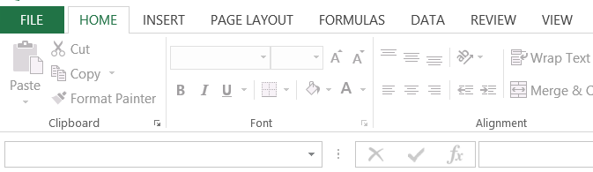

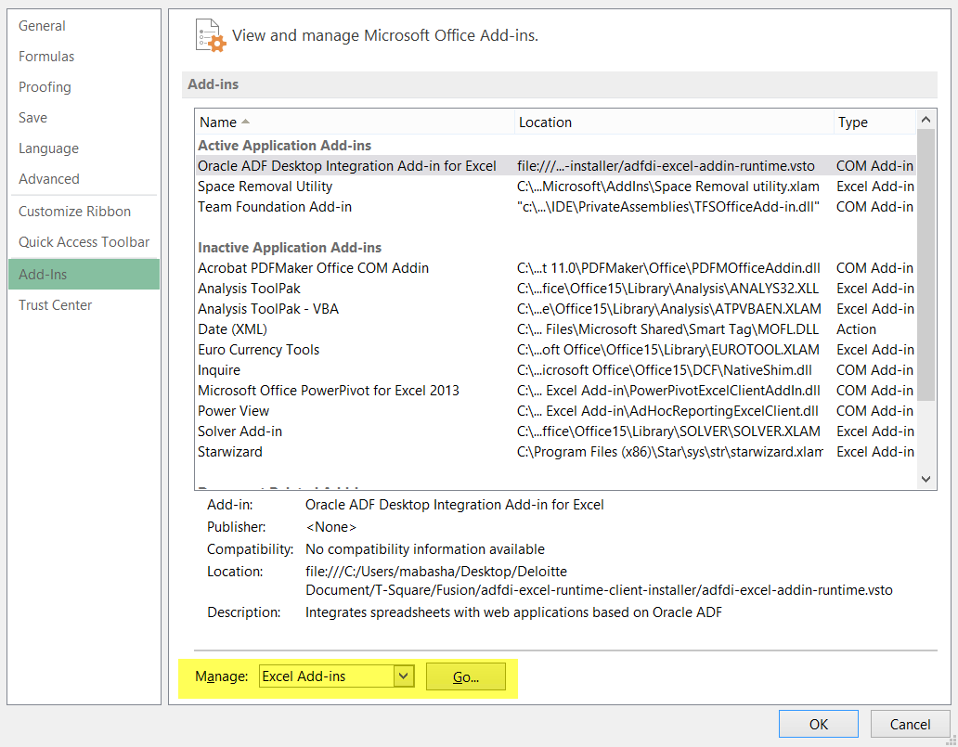

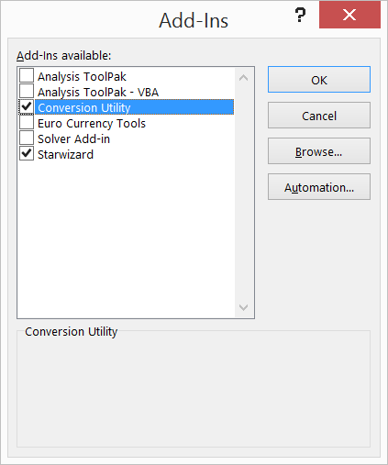

1. Training.

This utility allows users to perform below functions.

1. Extra space search which is classified with below 3 scope.
   * Current workbook including all the sheets.
   * Current sheet.
   * Selected cells.
2. Search duplicates on single column or multiple consecutive columns.
3. Search and identify the special characters in data.
4. Concatenation and removal of strings which can be performed at below 2 levels.
   * Suffix.
   * Prefix.
5. SQL concatenation and removal.
6. Concatenate consecutive columns.
7. Split cell data based on delimiter.
8. Open csv/tab delimited file.
9. Create csv file.
10. Create tab delimited file.
11. Open any delimited file.
12. Create any delimited file.
13. Open an XML file.
14. Create an XML file.
15. Compare FBDI templates.
16. Copy comments from FDBI template.
17. Create SQL script based on FBDI template.
18. Save current excel to smaller size file.

Below are the explanations of functions that utility can perform.

1. **Entire workbook including all the sheets in current workbook.**

* Open excel workbook, where you would like to validate extra space issue.
* Go to “CONVERSION UTILITY” tab.
* Click on “All sheets search”.
* System will search for invalid data in current workbook and mark them in RED font.
* If such entries found, system will prompt “Extra spaces exist, please review data.”.
* If no entries found, system will prompt “No extra spaces found.”.
* **To remove errored entries, click on “Remove from all Sheets”**

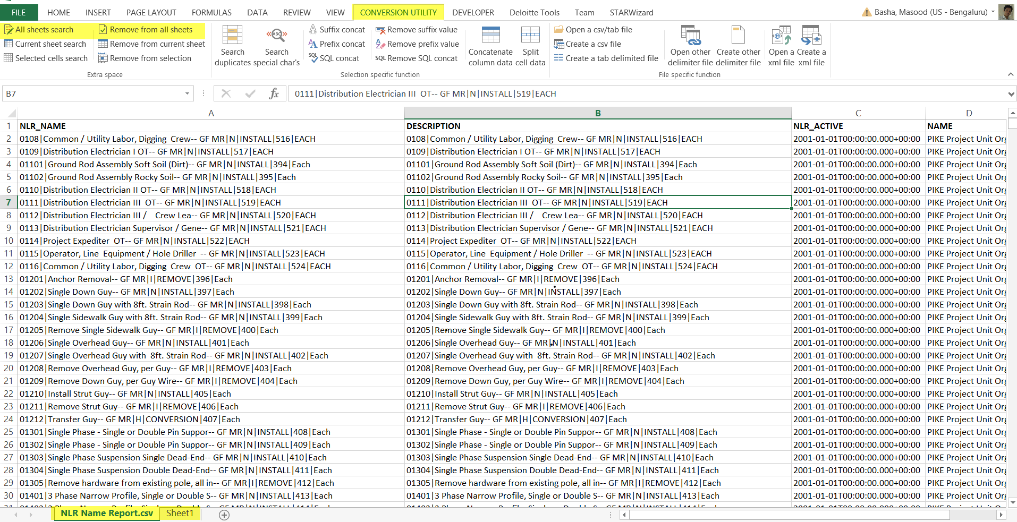

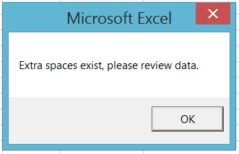 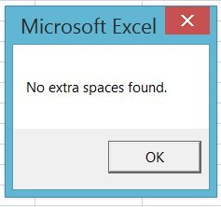

1. **Current sheet.**

* Open excel sheet, where you would like to validate extra space issue.
* Go to “CONVERSION UTILITY” tab.
* Click on “Current sheets search”.
* System will search for invalid data in current sheet and mark them in RED font.
* If such entries found, system will prompt “Extra spaces exist, please review data.”.
* If no entries found, system will prompt “No extra spaces found.”.
* **To remove errored entries, click on “Remove from current Sheets”**

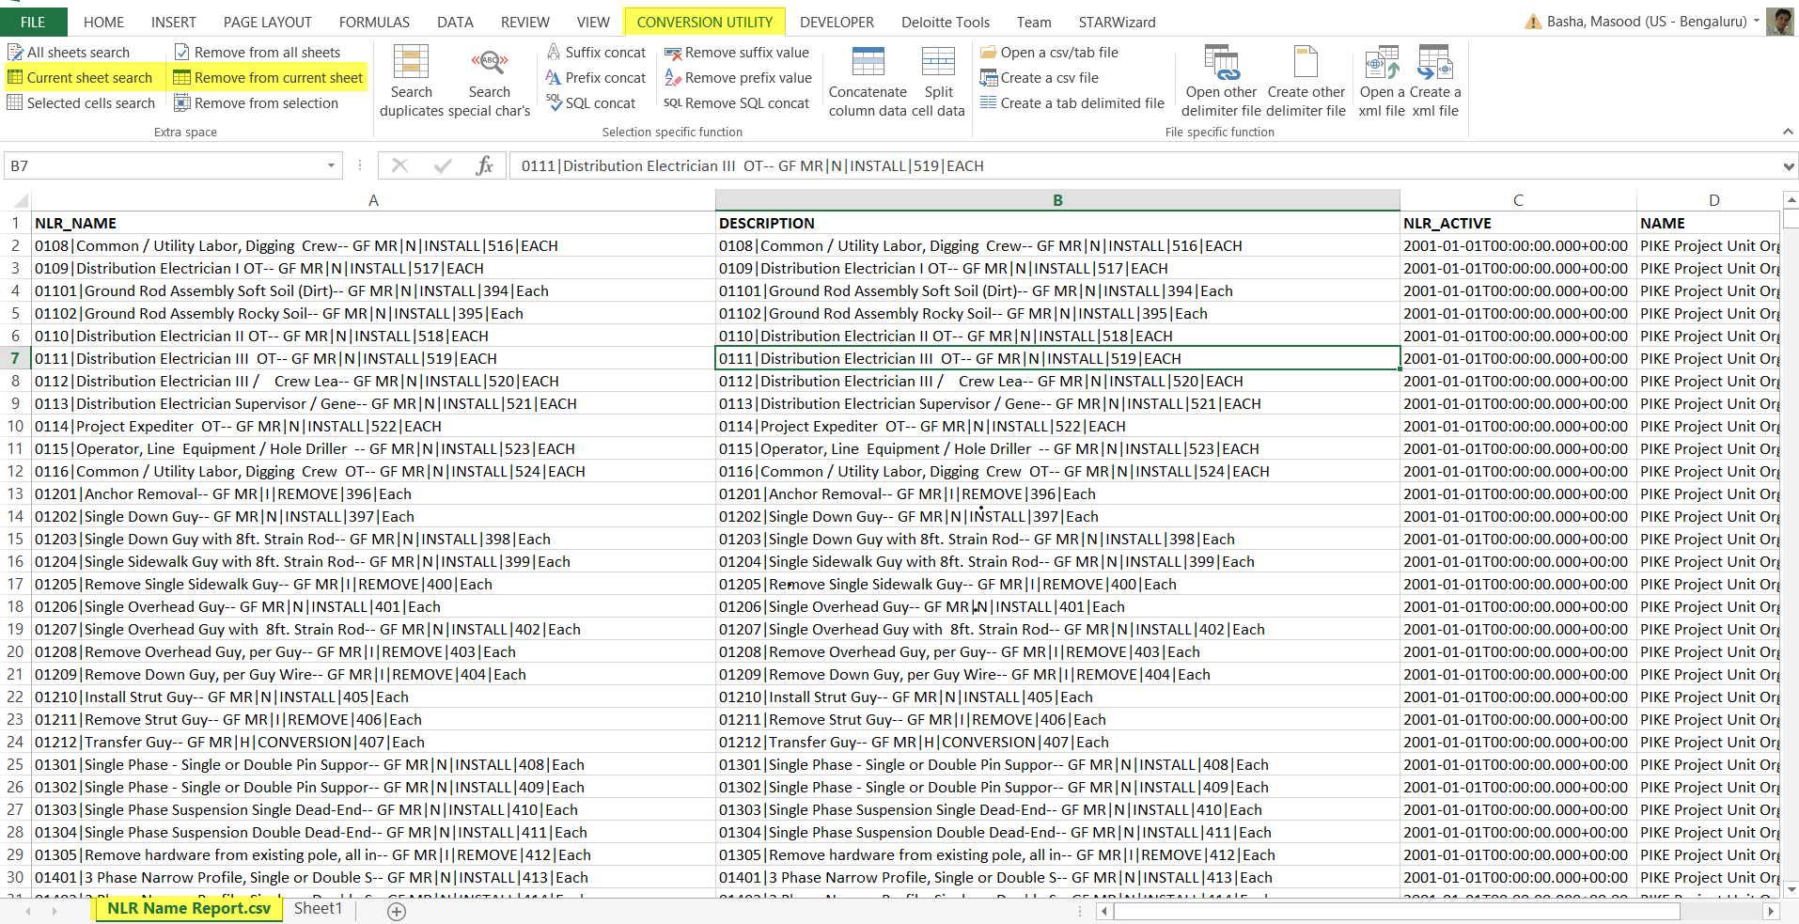

 

1. **Selected cells.**

* Open excel sheet, where you would like to validate extra space issue.
* Go to “CONVERSION UTILITY” tab.
* Click on “Selected Cells search”.
* System will search for invalid data in selected area and mark them in RED font.
* If such entries found, system will prompt “Extra spaces exist, please review data.”.
* If no entries found, system will prompt “No extra spaces found.”.
* **To remove errored entries, click on “Remove from selected cells”**

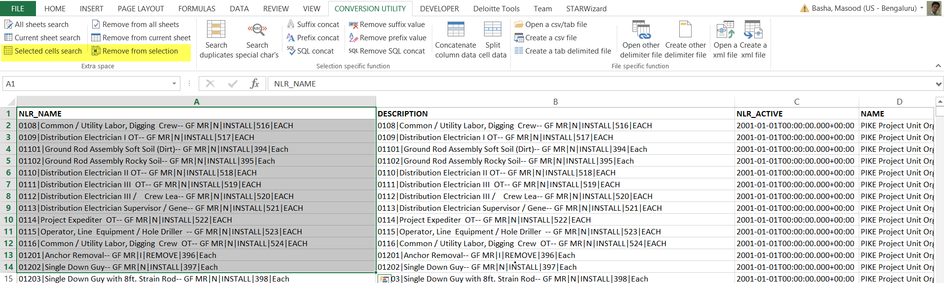

 

**Note**: For this type of search, please don’t select entire column or entire row instead use ctrl+down or ctrl+up or ctrl+right or ctrl+left to select cells which have data.

1. **Selected cells duplicate search.**

* Open excel sheet, where you would like to validate duplicated entries issue.
* Select a single column or multiple consecutive columns.
* Go to “CONVERSION UTILITY” tab.
* Click on “Search duplicates”.
* System will search for duplicate data in selected area and mark them in RED font.
* If such entries found, system will prompt “Duplicate entries exist, please review data.”.
* If no entries found, system will prompt “No duplicates found.”.
* ***If multiple consecutive columns are selected, system will insert a column concatenate the values and provide the results.***

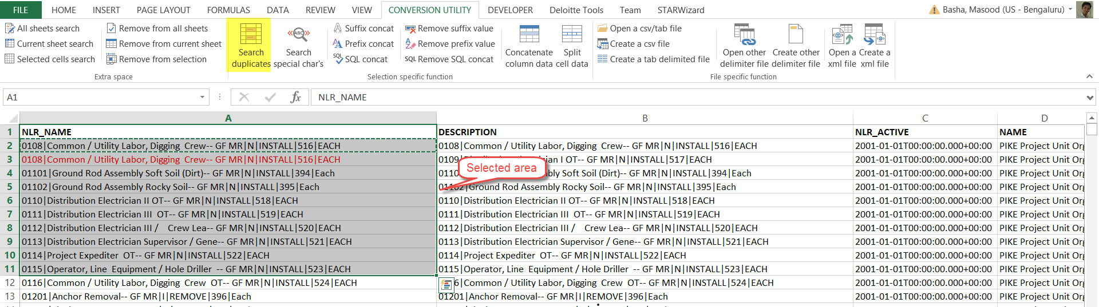

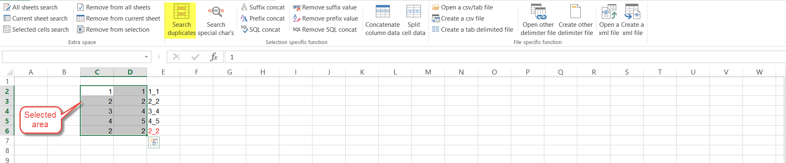

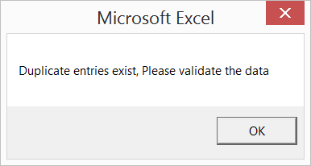 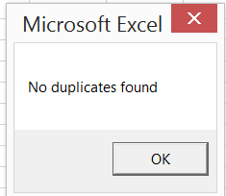

**Note**: For this type of search, please don’t select entire column or entire row instead use ctrl+down or ctrl+up or ctrl+right or ctrl+left to select cells which have data.

**Don’t select empty cells for comparison, SYSTEM WILL FAIL TO PERFORM DESIRED FUNCTION**.

1. **Selected cells Special character search.**

* Open excel sheet, where you would like to validate duplicated entries issue.
* Select cells where you wish to perform special character search.
* Go to “CONVERSION UTILITY” tab.
* Click on “Search special characters”.
* System will search for special characters in selected area and mark them in RED font.
* The special characters are shown in the “$PeC!aL Char Sheet” tab.
* If such entries found, system will prompt “Special characters exist, please review data.”.
* If no entries found, system will prompt “No special characters found.”.

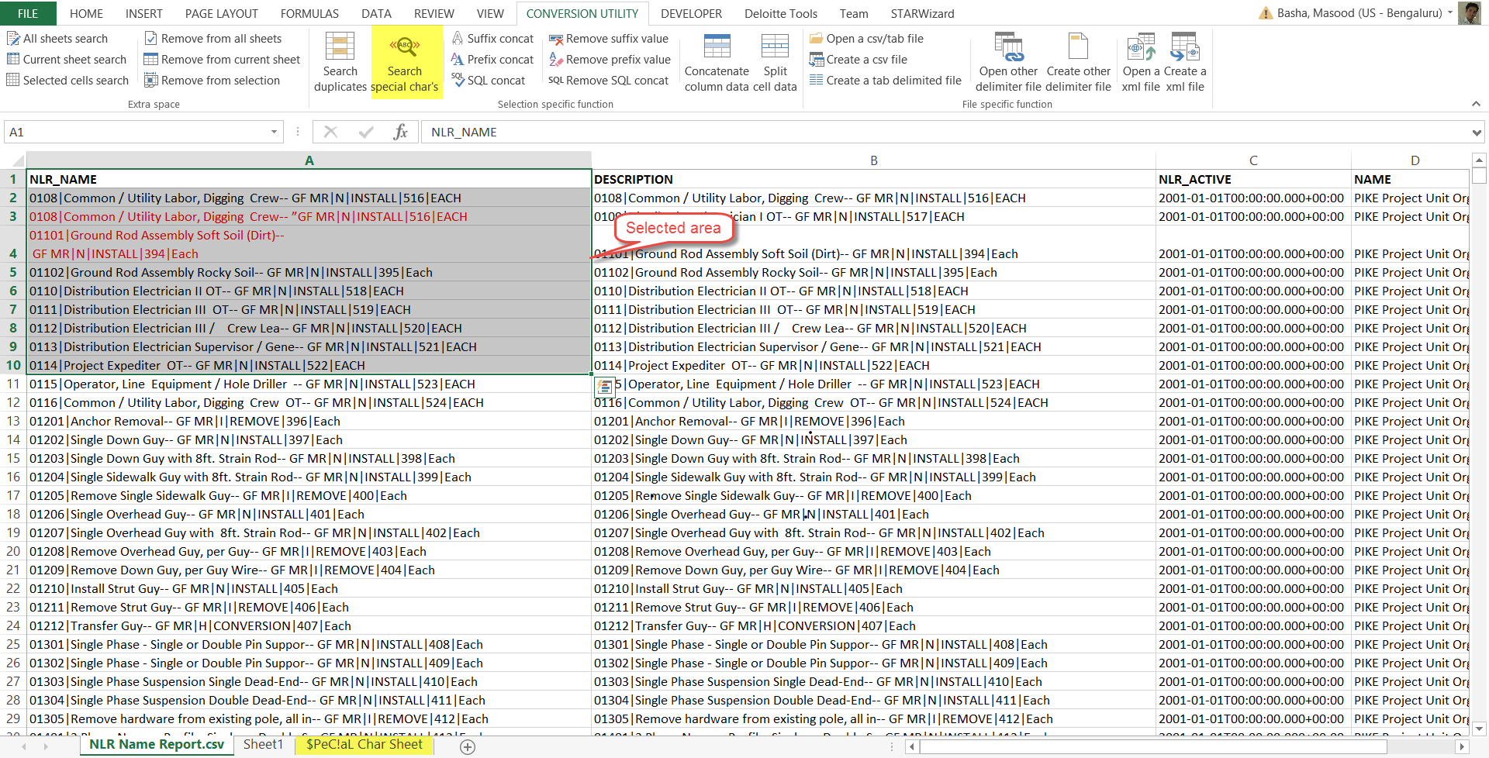

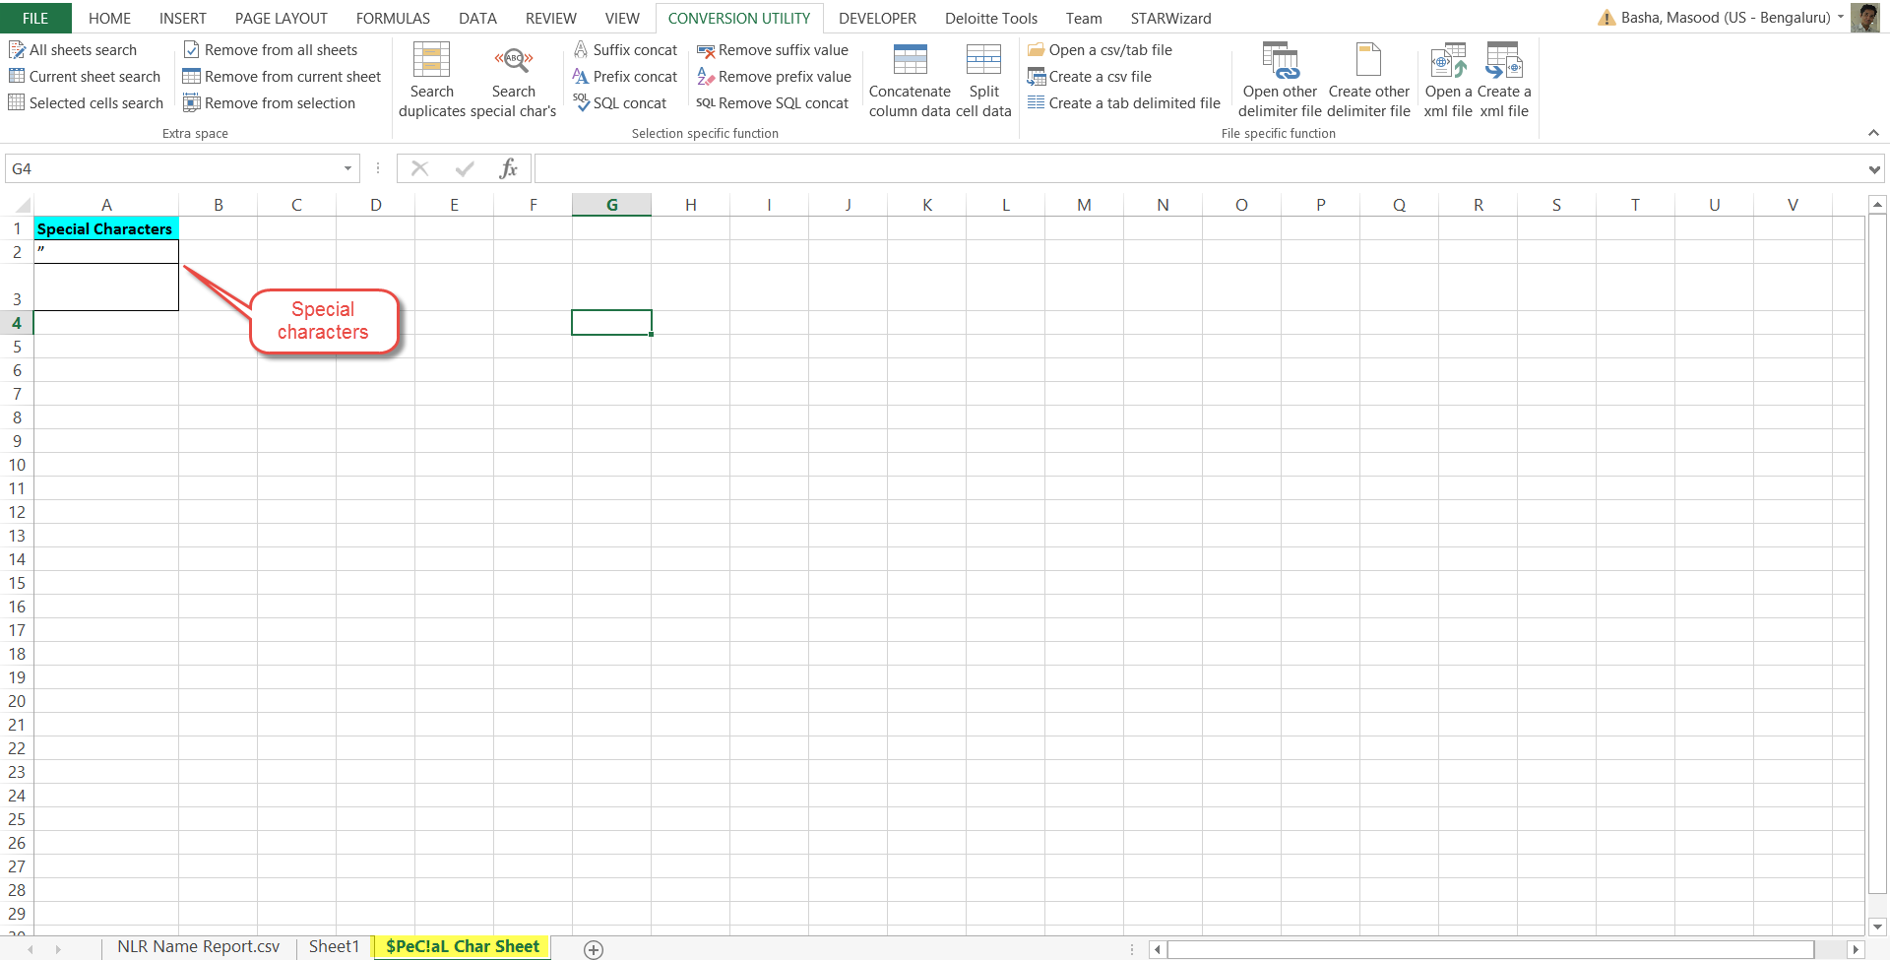

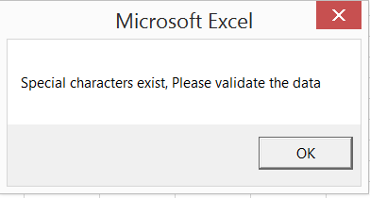 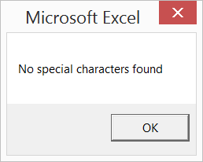

**Note**: For this type of search, please don’t select entire column or entire row instead use ctrl+down or ctrl+up or ctrl+right or ctrl+left to select cells which have data.

1. **Suffix concatenation and removal.**

* Open excel sheet.
* Select cells where you wish to perform suffix concatenation or removal.
* Go to “CONVERSION UTILITY” tab.
* Click on “Suffix concat”.
* System will prompt the concatenation string.
* Concatenation string is appended at the end of each selected cell value.
* Once the task is done, system will prompt that concatenation is complete.

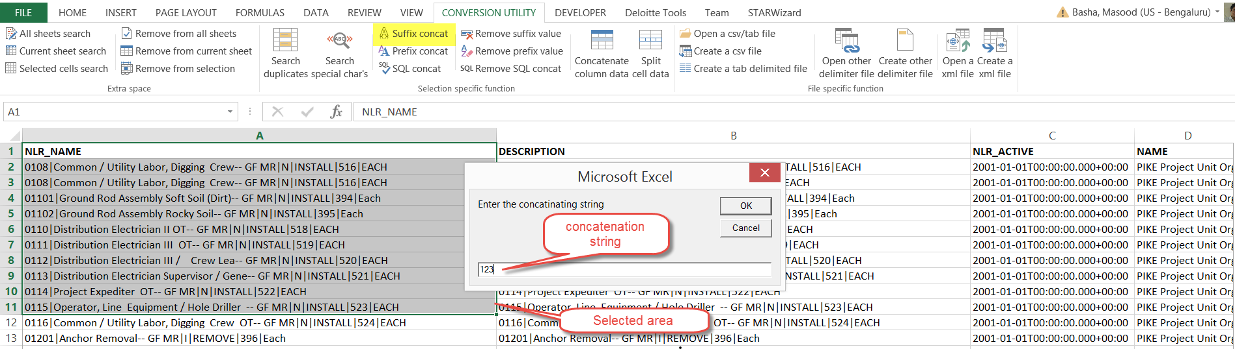

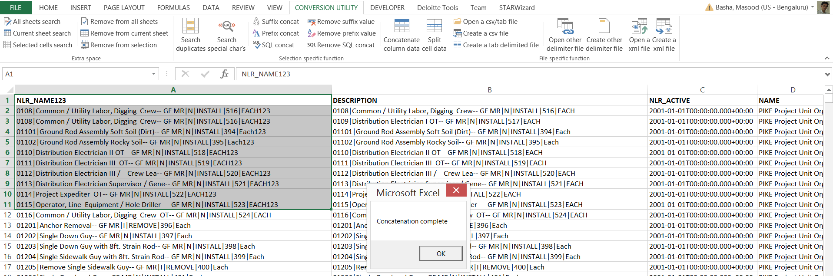

**To remove some value at the end of the cell value.**

* Go to “CONVERSION UTILITY” tab.
* Click on “Remove suffix value”.
* System will prompt the removable string.
* Removable string is removed at the end of each selected cell value.
* Once the task is done, system will prompt that concatenation is complete.

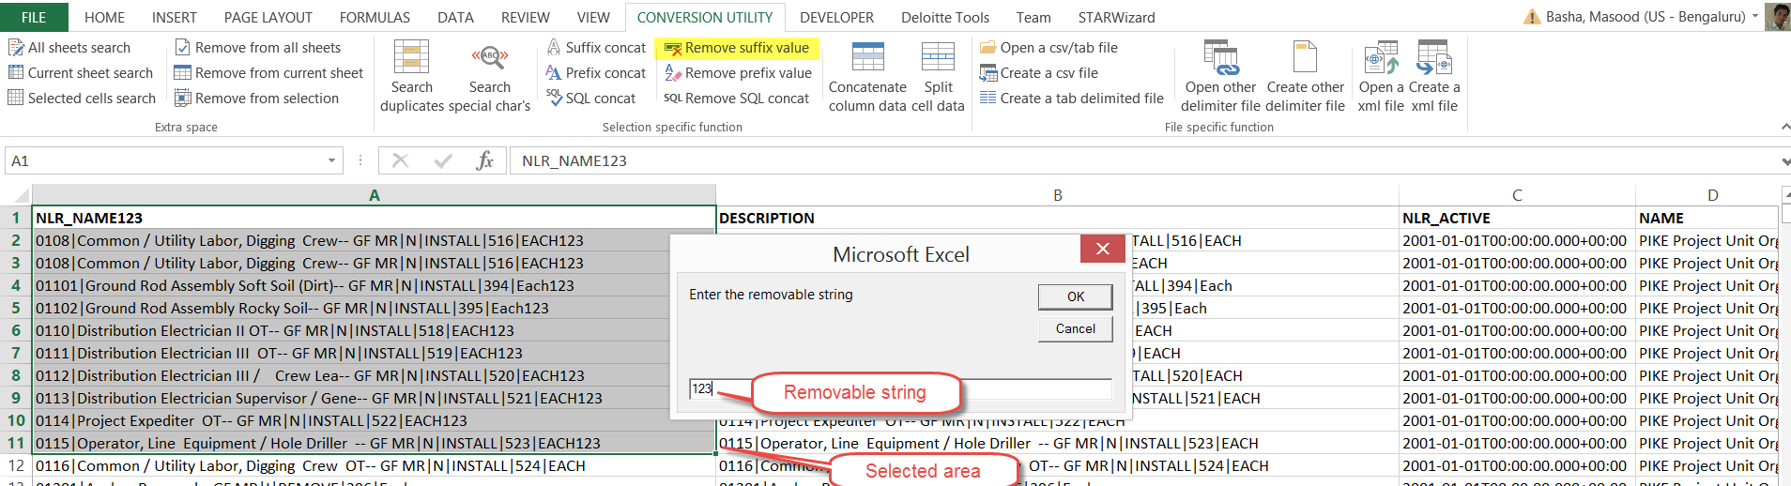

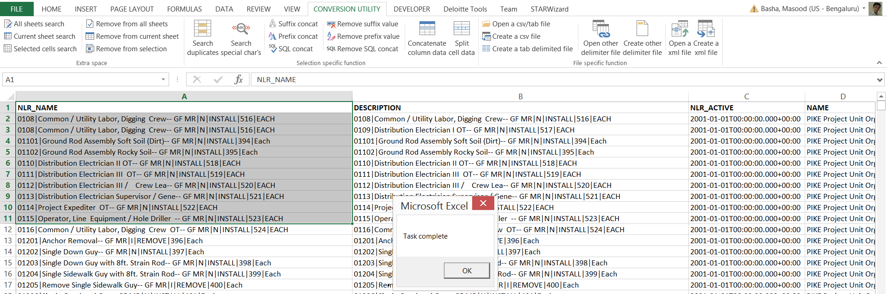

**Note**: For this type of search, please don’t select entire column or entire row instead use ctrl+down or ctrl+up or ctrl+right or ctrl+left to select cells which have data.

1. **Prefix concatenation and removal.**

* Open excel sheet.
* Select cells where you wish to perform prefix concatenation or removal.
* Go to “CONVERSION UTILITY” tab.
* Click on “Prefix concat”.
* System will prompt the concatenation string.
* Concatenation string is appended at the end of each selected cell value.
* Once the task is done, system will prompt that concatenation is complete.

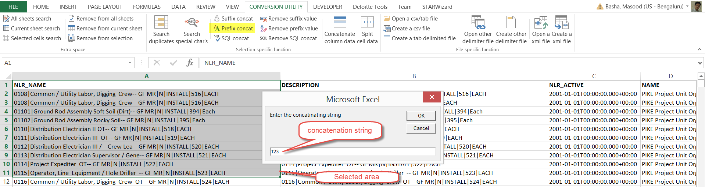

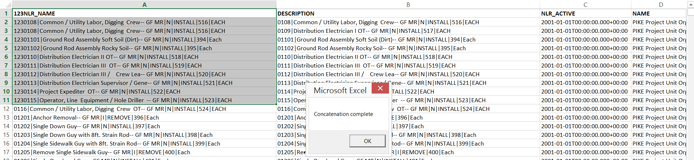

**To remove some value at the end of the cell value.**

* Go to “CONVERSION UTILITY” tab.
* Click on “Remove suffix value”.
* System will prompt the removable string.
* Removable string is removed at the end of each selected cell value.
* Once the task is done, system will prompt that concatenation is complete.

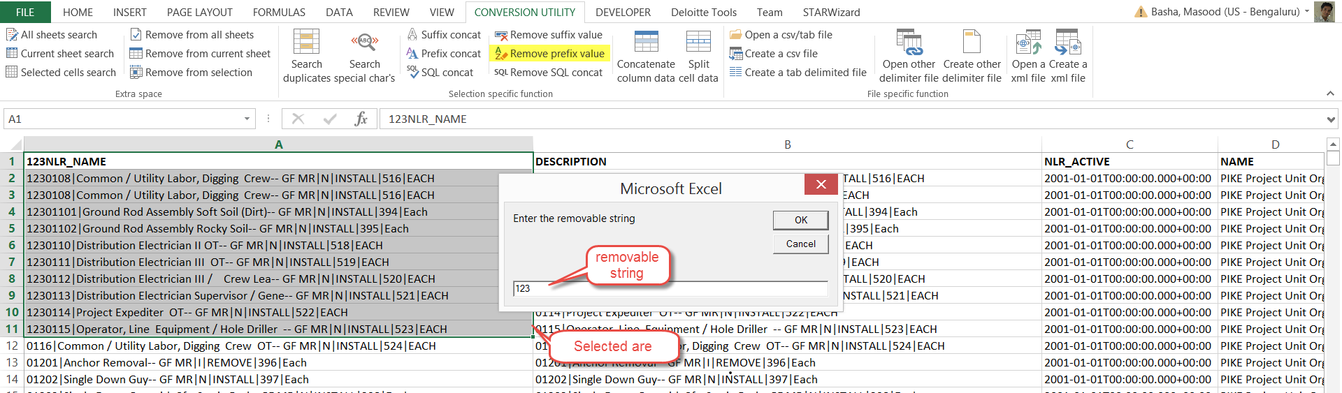

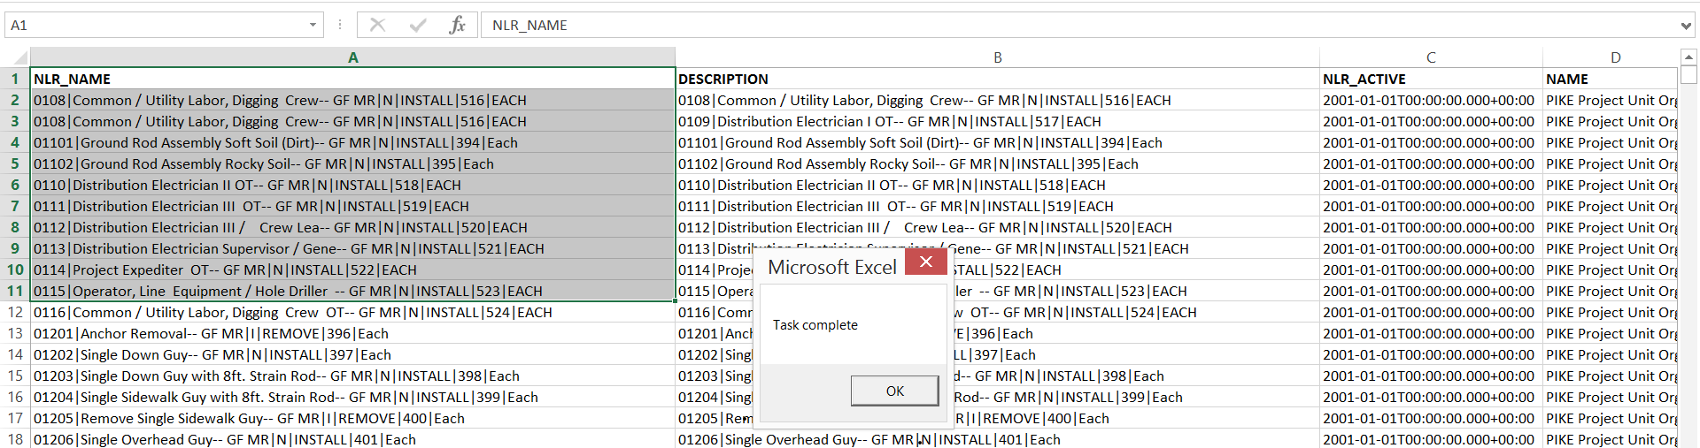

**Note**: For this type of search, please don’t select entire column or entire row instead use ctrl+down or ctrl+up or ctrl+right or ctrl+left to select cells which have data.

1. **SQL concatenation and removal.**

* Open excel sheet.
* Select cells where you wish to perform SQL concatenation or removal.
* Go to “CONVERSION UTILITY” tab.
* Click on “SQL concat”.
* Once the task is done, system will prompt that concatenation is complete.

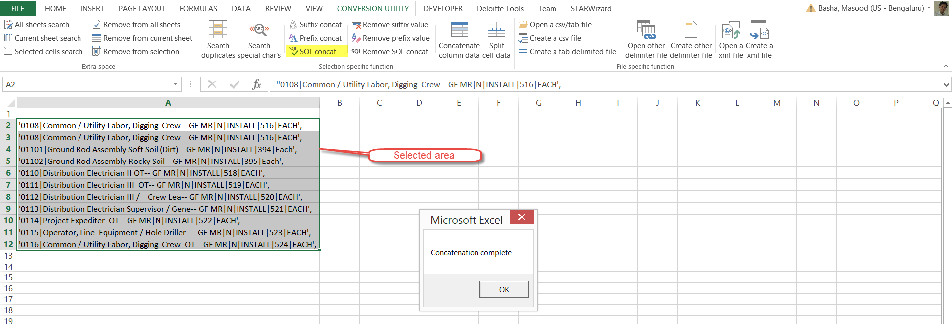

**To remove SQL concatenation.**

* Go to “CONVERSION UTILITY” tab.
* Click on “Remove sql concat”.
* Once the task is done, system will prompt that concatenation is complete.

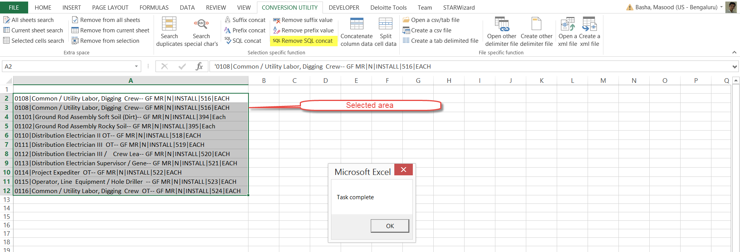

**Note**: For this type of search, please don’t select entire column or entire row instead use ctrl+down or ctrl+up or ctrl+right or ctrl+left to select cells which have data.

1. **Concatenate column data.**

* Open excel sheet.
* Select cells where you wish to perform concatenation.
* Go to “CONVERSION UTILITY” tab.
* Click on “Concatenate column data”.
* System will prompt for delimiter character.
* System will concatenate the data and prompts “Concatenation is complete”.

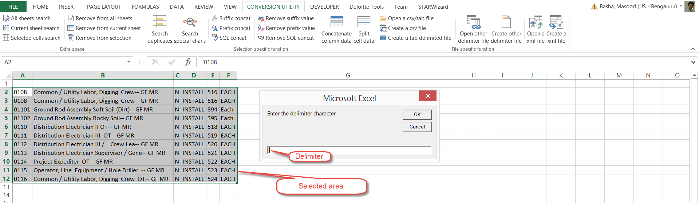

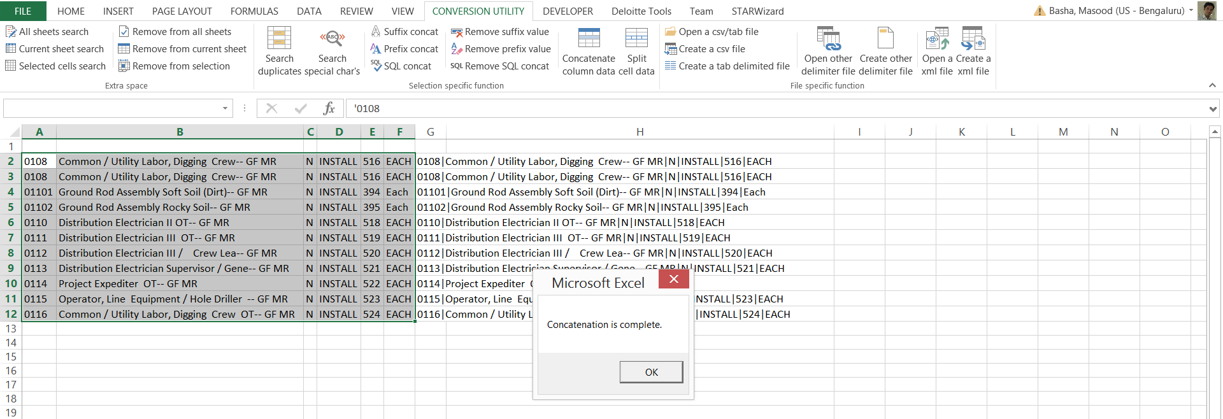

1. **Split cell data.**

* Open excel sheet.
* Select cells where you wish to perform split.
* Go to “CONVERSION UTILITY” tab.
* Click on “Split cell data”.
* System will prompt for delimiter character.
* System will concatenate the data and prompts “Spliting is complete”.

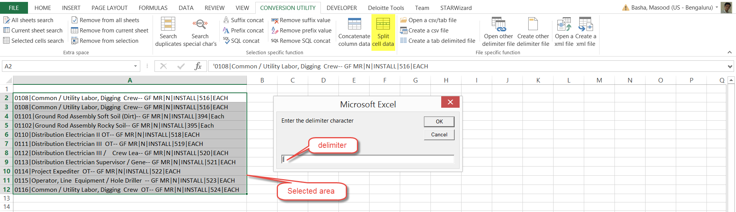

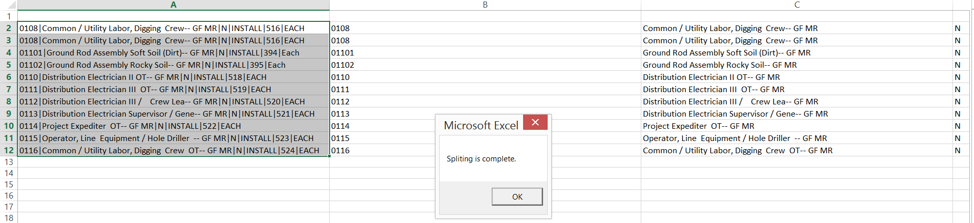

**Note**: For this type of search, please don’t select entire column or entire row instead use ctrl+down or ctrl+up or ctrl+right or ctrl+left to select cells which have data.

1. **Open a csv/tab file.**

* Open excel sheet.
* Go to “CONVERSION UTILITY” tab.
* Click on “Open a csv/tab file”.
* Browse the file you wish to open

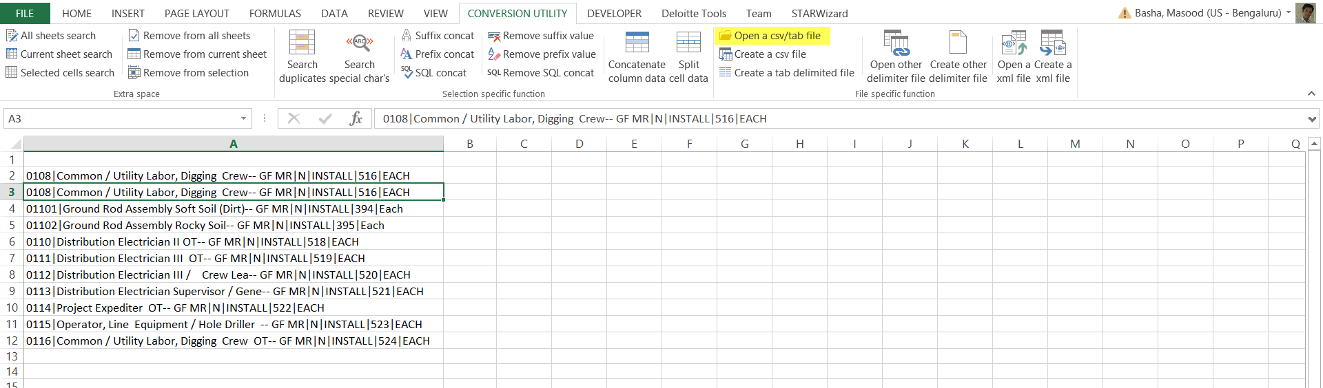

1. **Create a csv file.**

* Open excel sheet.
* Go to “CONVERSION UTILITY” tab.
* Click on “Create a csv file”.
* System will create a csv file in the same location as excel you have opened.



1. **Create a tab delimited file.**

* Open excel sheet.
* Go to “CONVERSION UTILITY” tab.
* Click on “Create a tab delimited file”.
* System will create a txt file in the same location as excel you have opened.



1. **Open other delimiter file.**

* Open excel sheet.
* Go to “CONVERSION UTILITY” tab.
* Click on “Open other delimiter file”.
* Browse the file you wish to open.
* System will prompt for the delimiter so split the file data.

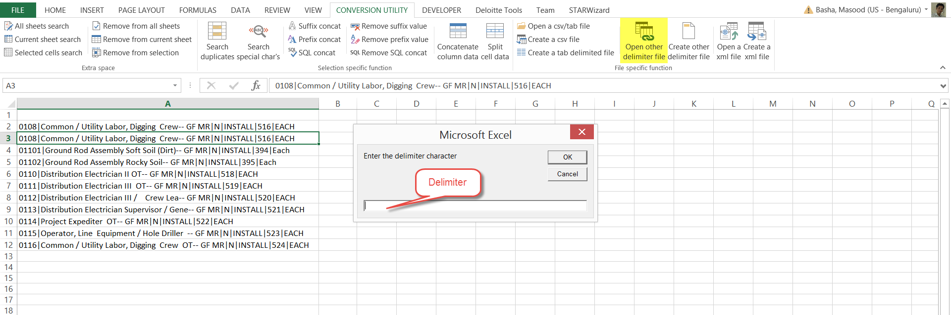

1. **Create other delimiter file.**

* Open excel sheet.
* Go to “CONVERSION UTILITY” tab.
* Click on “Create other delimiter file”.
* System will prompt for the delimiter.
* System will create a dat file in the same location as excel you have opened.

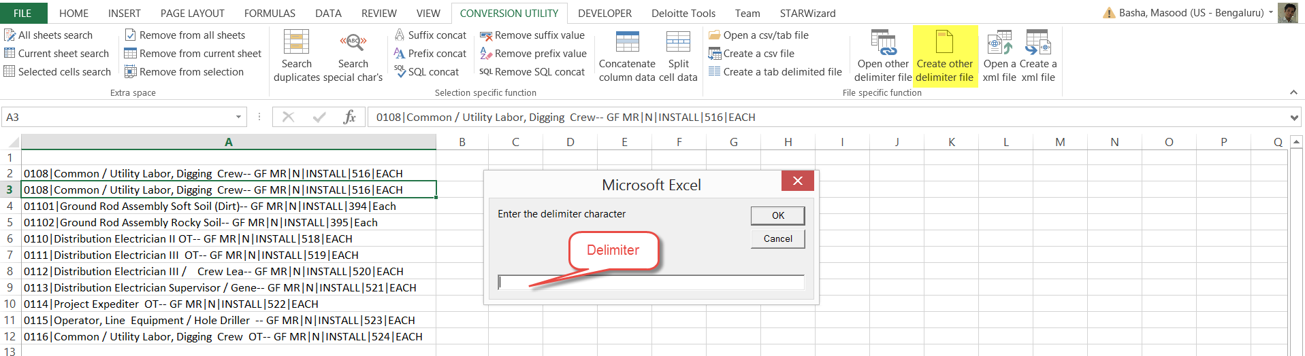

1. **Open an xml file.**

* Open excel sheet.
* Go to “CONVERSION UTILITY” tab.
* Click on “Open a xml file”.
* Browse the file you wish to open.



1. **Create an xml file.**

* Open excel sheet.
* Go to “CONVERSION UTILITY” tab.
* Click on “Create an xml file”.
* System will prompt for the location to store the xml file.
* System will create an xml file.



1. **Compare FBDI templates.**

* Open excel sheet.
* Go to “CONVERSION UTILITY” tab.
* Click on “Compare FBDI templates”.
* System will prompt to browse 2 FBDI templates.
* A new tab will be created showing the difference between the templates.



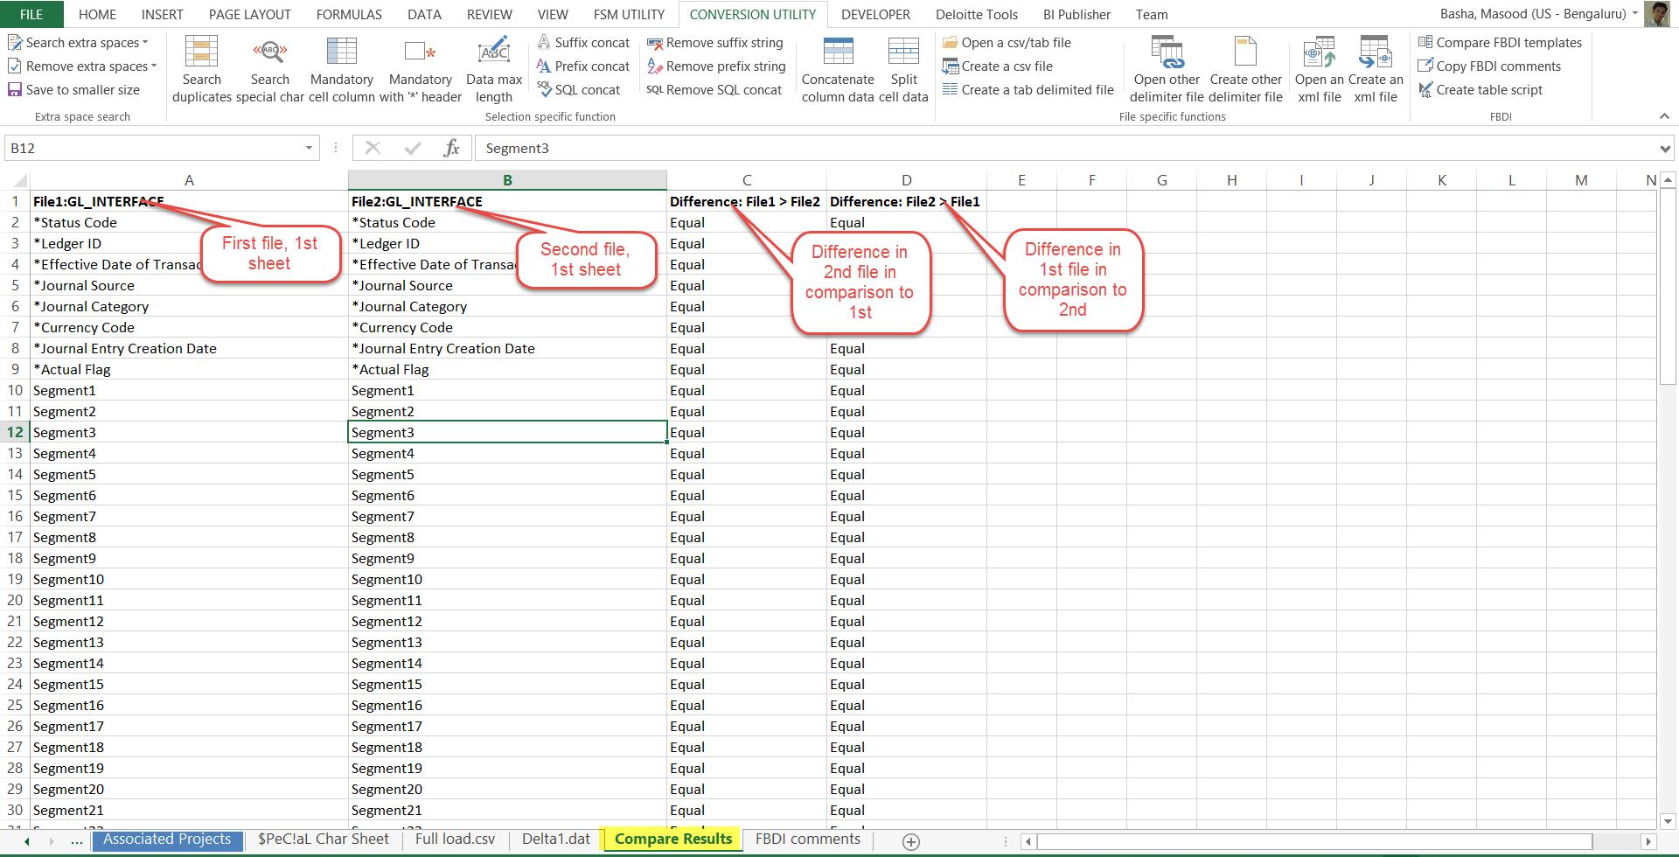

1. **Copy FBDI comments.**

* Open excel sheet.
* Go to “CONVERSION UTILITY” tab.
* Click on “Copy FBDI comments”.
* System will prompt to browse FBDI template.
* A new tab will be created showing the column name and its respective comments.



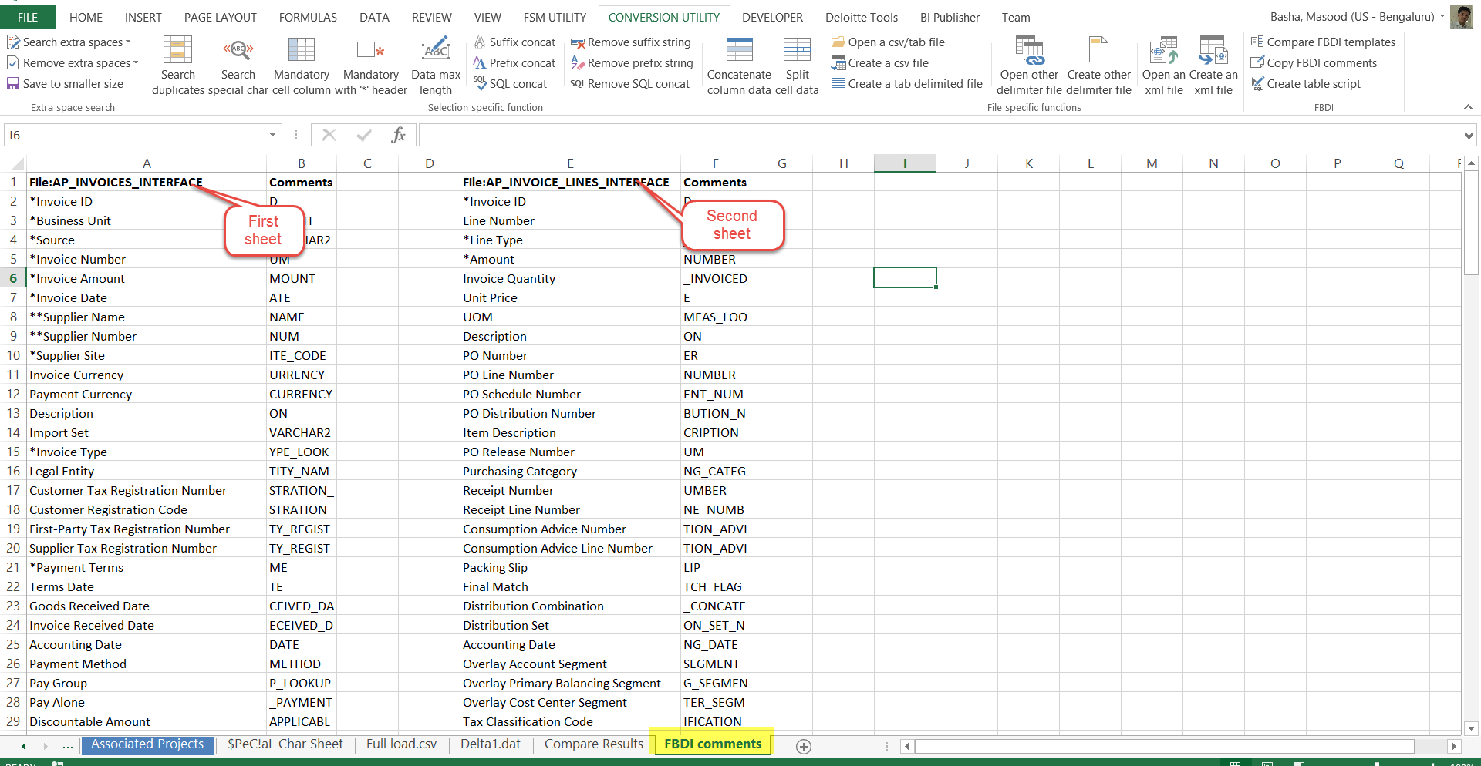

1. **Create table script.**

* Open excel sheet.
* Go to “CONVERSION UTILITY” tab.
* Click on “Create table script”.
* System will prompt to browse FBDI template.
* System will prompt for the file name for SQL script.



1. **Create table script.**

* Open excel sheet.
* Go to “CONVERSION UTILITY” tab.
* Click on “Save to smaller size”.
* System will automatically saves the current file into a binary excel file with much lesser size.

